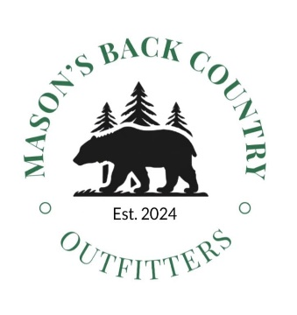
MBCO Hunting/Wounding Policy
At MBCO, we take pride in encouraging ethical hunting and conservation of our resources. We understand that hunters get excited while hunting and bad shots can happen. We as a team, commit to reasonable recovery efforts on every shot taken. We will track a blood trail for up to 800m or at the guides discretion. Small drops of blood can be a sign of a poor shot and lowers the chance of recovery. At dark, it is at the guides discretion, depending on amount of sign or blood trail, to recover the animal or return to the site in the morning to continue tracking. The woods of Nova Scotia are generally very dense and daytime tracking is generally preferred. You as the hunter can assist in these efforts by listening carefully after the shot for a death moan, paying attention to the direction of the fleeing animal , and staying in your stand until the guide arrives which is MANDATORY. We will do everything we can to recover your harvest and get lots of photos!
A wounded animal is considered a DEAD animal, meaning if there is blood or flesh drawn, and we cannot recover the bear, the hunt is considered over. It is extremely important to be patient and wait for the bear to get to the barrel and to judge the size and sex of the animal before deciding to shoot. Rushing shots can lead to wounded and unrecovered animals, or sows being killed that have cubs in the woods nearby. If you feel you are having trouble judging bears, just ask for more help and clarification from your guide.
Here at MBCO, we are fortunate to have the hunting territory that we do with a combination of crown land and private property (with permission). As such, there are some rules for us when hunting. There is a ZERO tolerance for alcohol or drug use/possession while hunting. We have a zero tolerance for any alcohol or drug use prior to hunting as there are enough risks as is and we want to keep everyone safe.
Once your hunt is over, in the evenings or after you tag out, by all means relax and dive in.
Final note, listen to your guides and be patient, wait for the right shot and make sure to judge the bears size and sex. Avoid shooting sows with cubs. Aim small and true and most importantly, HAVE FUN!

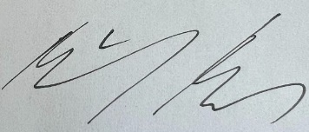
Mike Mason - Owner

