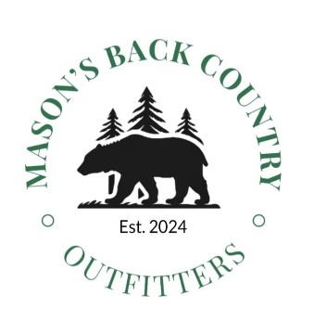
MBCO Hunter Questionnaire
At MBCO, we take pride in offering our hunters the best experience possible. As such, this questionnaire allows us to get to know some aspects about our hunters to make their experience as positive, safe, personable and comfortable as possible.
Printed Name:_______________________________________ Date:______________________________

- Have you hunted black bears before? ( Yes / No )

- What hunting tool will you be using to hunt? ( Gun / Bow / Crossbow)

- Do you have an emergency contact? If yes, please provide name and phone number. _____________________________________________________________________________________

- Do you have any allergies? _____________________________________________________________________________________

- Do you have any dietary restrictions?
_____________________________________________________________________________________

- Do you have any medical conditions that we need to be made aware of in the event of an emergency?
_____________________________________________________________________________________

- How do you prefer hunting? Circle all that apply: ( ground blind / ladder stand / tree stand / no preference)

- Do you have the physical ability to climb a ladder? ( Yes / No )

- Do you have the physical ability to walk rugged train for 10-15 minutes? ( Yes / No )

- Are you willing to sit in a blind or stand after dark while you await your guide to come get you? (Yes / No)

- Do you have the physical ability to sit in a stand for 3+ hours at a time? ( Yes / No )

- Do you know how to drive an ATV? ( Yes / No )

- If yes to #12, are you willing to drive an ATV to get to a hunting location ( Yes / No )

- What smartphone make and model do you use? (We ask this question because some of our hunting locations have no cell service and some newer model phones have capabilities such as Satellite calling/texting) _____________________________________________________________________________________

